Assignment #1 Submittion

前四个部分，是针对每个stage的要求，显示的完成内容。

最后一个部分，是根据要求，提交的内容。

# Stage 1: Building the EC2 web server

1. **the instance should be of type t1.micro.**

从以下的截图中可以看出，instance type 是t1.micro。

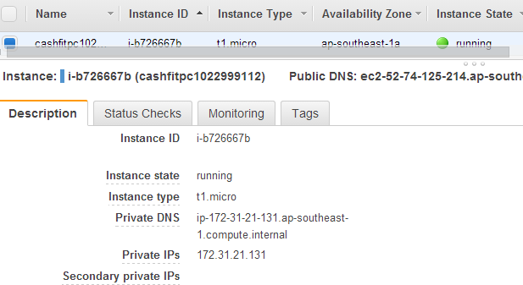

1. **the instance should reside within region ap-southeast-1 within availability zone ap-southeast-1a.**

从AWS console的URL可以看出是ap-southeast-1。

<https://ap-southeast-1.console.aws.amazon.com/ec2/v2/home?region=ap-southeast-1#Instances:sort=instanceId>

从右上角的region里看出，是Asia Pacific (Singapore)。Asia Pacific (Singapore)就是指ap-southeast-1 region。

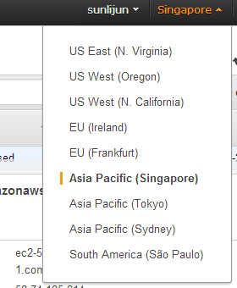

从下面截图中可以看出availability zone是ap-southeast-1a

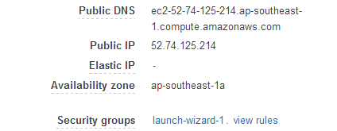

1. **the instance should use a 1 GiB attached EBS volume and contain a valid partition**

**table with one partition. The partition should contain a valid file system.**

从左侧导航里的Elastic Block Store 中的Volumes可以看出，大小1GiB。并且已经attach 到上面的EC2 instance上。

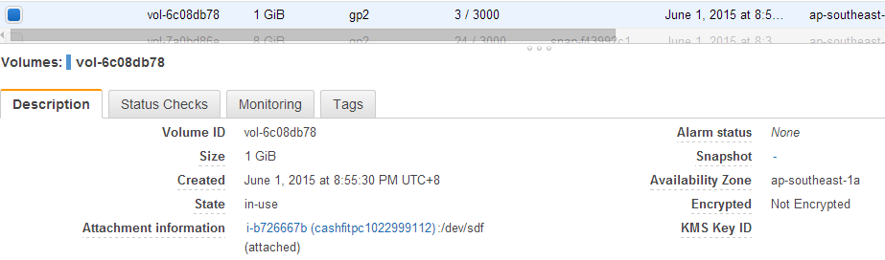

文件系统通过命令mkfs创建，并且已经挂载到/mnt/my-data上。

以下为命令df显示的结果。

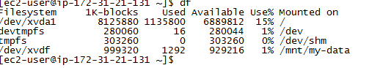

1. **the file system residing on the EBS volume should be mounted automatically upon**

**reboot of the EC2 instance.**

下图最后一行即为文件系统自动挂载的配置。

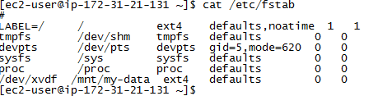

通过reboot验证，符合自动挂载要求。

1. **the instance should serve web pages via an appropriate service such as Apache or**

**IIS. This service should start automatically upon boot.**

通过yum命令安装Apache服务。

[ec2-user@ip-172-31-21-131 ~]$ sudo service httpd status

httpd (pid 1447) is running...

httpd服务已经配置为自动启动。通过reboot验证，正常。

[ec2-user@ip-172-31-21-131 ~]$ chkconfig |grep httpd

httpd 0:off 1:off 2:on 3:on 4:off 5:on 6:off

1. **the instance should serve a web page “index.html” containing well-formed HTML**

**displaying the text "Hello AWS World" and display the screen shots created below in**

**Stage 3 (they will be hosted separately). The HTML file should reside on the file**

**system within the previously created EBS volume and be served as the default**

**document from the web server root.**

在EBS文件系统上，创建了index.html文件。

[ec2-user@ip-172-31-21-131 public_html]$ pwd;ls -l

/mnt/my-data/public_html

total 4

-rw------- 1 apache apache 802 Jun 2 11:18 index.html

[ec2-user@ip-172-31-21-131 public_html]$

编辑文件内容，显示Hello AWS World及其他截图。见URL：

<http://loadbalancer-1285124779.ap-southeast-1.elb.amazonaws.com/>

html文件内容：

|  |
| --- |
| <!DOCTYPE html>  <html>  <head>  <title>AWS Fundamentals-Assignment #1 by cashfitpc1022999112  </title>  </head>  <body>  <p>  <h2> Hello AWS World </h2>  </p>  <hr>  <p>  <h2> screen-shot1: The mounted EBS volume </h2>  <br>  <img src="https://s3-ap-southeast-1.amazonaws.com/bucketcashfit/screen-shot1.png" alt="screen-shot1" align="middle">  </p>  <hr>  <p>  <h2> screen-shot2: index.html file in the EBS volume (/mnt/my-data/public_html) </h2>  <br>  <img src="https://s3-ap-southeast-1.amazonaws.com/bucketcashfit/screen-shot2.png" alt="screen-shot2" align="middle">  </p>  <hr>  <p>  <h2> screen-shot3: Web server configuration to serve index.html from the EBS volume </h2>  <br>  <img src="https://s3-ap-southeast-1.amazonaws.com/bucketcashfit/screen-shot3.png" alt="screen-shot3" align="middle">  </p>  </body>  </html> |

1. **the instance should use Security Groups effectively to allow administration and**

**serve HTTP.**

从以下看出安全组策略：

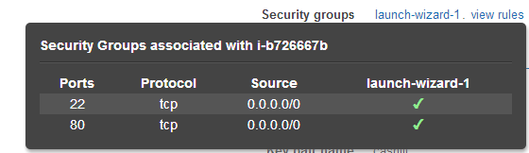

# Stage 2: Configuring the Elastic Load Balancer

1. **the ELB should be created in the Singapore region.**

创建ELB时，注意右上角的region是Singapore。



1. **the ELB should accept HTTP on port 80.**

见如下截图：



1. **the Healthy Threshold for the ELB to be set to 2**

见如下截图：

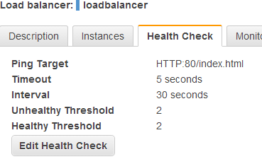

1. **deliver traffic to the EC2 instance created in Stage 1.**

见如下截图，

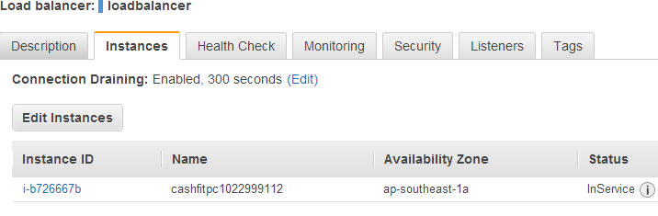

# Stage 3: Configuring S3

1. **the bucket should be created in the Singapore region.**

选择S3服务，创建时，选择Singapore。

后续，在查看bucket属性时也可以看到region。

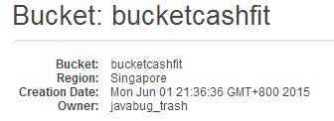

1. **the bucket should be publicly readable.**

设置bucket权限，如下：

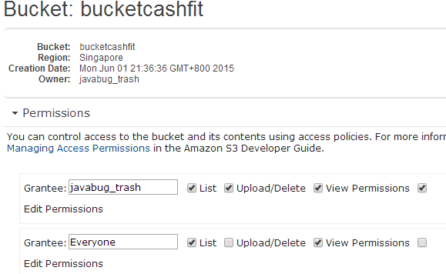

从bucket中可以看到上传的文件：screen-shot1.png，screen-shot2.png，screen-shot3.png。

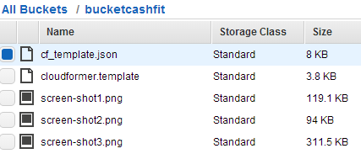

文件内容可以查看以下URL：

<http://loadbalancer-1285124779.ap-southeast-1.elb.amazonaws.com/>

image文件的URL，都是S3的地址:

<img src="https://s3-ap-southeast-1.amazonaws.com/bucketcashfit/screen-shot1.png" alt="screen-shot1" align="middle">

<img src="https://s3-ap-southeast-1.amazonaws.com/bucketcashfit/screen-shot2.png" alt="screen-shot2" align="middle">

<img src="https://s3-ap-southeast-1.amazonaws.com/bucketcashfit/screen-shot3.png" alt="screen-shot3" align="middle">

# Stage 4: Create an Amazon Linux Web Server Using CloudFormation (CFN) Template

1. **Parameters - Instance type of “t2.micro” as default. Provide option to allow choosing instance types of others such as “t2.small” and “t2.medium” as well. [2 marks]**

设置parameter：InstanceType。

Default参数指定默认值。Allowdvalues指定可选值。

题目中举例说可以选择t2的另外两种类型。但并未限定其他的不可选，所以我的代码中有更多的其他选项。与要求并无不符。

|  |
| --- |
| "InstanceType" : {  "Description" : "WebServer EC2 instance type",  "Type" : "String",  "Default" : "t2.micro",  "AllowedValues": [  "t1.micro",  "t2.micro",  "t2.small",  "t2.medium",  "m1.small",  "m1.medium",  "m1.large",  "m1.xlarge",  "m2.xlarge",  "m2.2xlarge",  "m2.4xlarge"  ], |

1. **Parameters - Allow user to specify EC2 key pair name that you want to associate**

**with this instance. Note: Name is required. [2 marks]**

见如下代码片段，限定了最短长度，确保keyName不为空。

实际上，根据文档，Parameter都不允许为空。即使不加长度限制，在实际执行时，会报错：输入的KeyName为空。

|  |
| --- |
| "KeyName": {  "Description" : "Name of an existing EC2 KeyPair to enable SSH access to the instance",  "Type": "AWS::EC2::KeyPair::KeyName",  "MinLength": "1",  "MaxLength": "255",  "AllowedPattern" : "[\\x20-\\x7E]*",  "ConstraintDescription" : "can't be null and contain only ASCII characters."  }, |

1. **Mappings of Amazon Machine Image (AMI) ID for all the regions for AWS except China Region and US Government Cloud. [2 marks]**

见如下代码，对各种类型的instance，加了与AMI的对应关系列表。

列表中的region没有China和US Government。

|  |
| --- |
| "Mappings" : {  "AWSInstanceType2Arch" : {  "t1.micro" : { "Arch" : "PV64" },  "t2.micro" : { "Arch" : "HVM64" },  "t2.small" : { "Arch" : "HVM64" },  "t2.medium" : { "Arch" : "HVM64" },  "m1.small" : { "Arch" : "PV64" },  "m1.medium" : { "Arch" : "PV64" },  "m1.large" : { "Arch" : "PV64" },  "m1.xlarge" : { "Arch" : "PV64" },  "m2.xlarge" : { "Arch" : "PV64" },  "m2.2xlarge" : { "Arch" : "PV64" },  "m2.4xlarge" : { "Arch" : "PV64" }  },  "AWSRegionArch2AMI" : {  "us-east-1" : {"PV64" : "ami-50311038", "HVM64" : "ami-5231103a", "HVMG2" : "ami-8c6b40e4"},  "us-west-2" : {"PV64" : "ami-5d79546d", "HVM64" : "ami-43795473", "HVMG2" : "ami-abbe919b"},  "us-west-1" : {"PV64" : "ami-eb4fa8af", "HVM64" : "ami-f74fa8b3", "HVMG2" : "ami-f31ffeb7"},  "eu-west-1" : {"PV64" : "ami-a71588d0", "HVM64" : "ami-a51588d2", "HVMG2" : "ami-d5bc24a2"},  "eu-central-1" : {"PV64" : "ami-ac5c61b1", "HVM64" : "ami-a25c61bf", "HVMG2" : "ami-7cd2ef61"},  "ap-northeast-1" : {"PV64" : "ami-8d1df78d", "HVM64" : "ami-a51df7a5", "HVMG2" : "ami-6318e863"},  "ap-southeast-1" : {"PV64" : "ami-887041da", "HVM64" : "ami-5e73420c", "HVMG2" : "ami-3807376a"},  "ap-southeast-2" : {"PV64" : "ami-bb1e6e81", "HVM64" : "ami-ad1e6e97", "HVMG2" : "ami-89790ab3"},  "sa-east-1" : {"PV64" : "ami-29aa1234", "HVM64" : "ami-27aa123a", "HVMG2" : "NOT_SUPPORTED"}  }  }, |

1. **EC2 security group to enable for accessing Web and SSH traffic from outside. [2 marks]**

允许web和ssh端口的访问。

|  |
| --- |
| "WebServerSecurityGroup" : {  "Type" : "AWS::EC2::SecurityGroup",  "Properties" : {  "GroupDescription" : "Enable HTTP access via port 80",  "SecurityGroupIngress" : [  {"IpProtocol" : "tcp", "FromPort" : "80", "ToPort" : "80", "CidrIp" : "0.0.0.0/0"},  {"IpProtocol" : "tcp", "FromPort" : "22", "ToPort" : "22", "CidrIp" : { "Ref" : "SSHLocation"}}  ]  }  } |

1. **Resource and User Data - Use a script in User Data to install and start Web Server. [4 marks]**

在resource里，有添加httpd服务的内容。

|  |
| --- |
| "Install" : {  "packages" : {  "yum" : {  "httpd" : []  }  }, |

创建index.html的代码：

|  |
| --- |
| "files" : {  "/var/www/html/index.html" : {  "content" : { "Fn::Join" : [ "", [  "<html>\n",  " <head>\n",  " <title>AWS CloudFormation by cashfit</title>\n",  " <meta http-equiv=\"Content-Type\" content=\"text/html; charset=ISO-8859-1\">\n",  " </head>\n",  " <body>\n",  " <h1>Welcome to the AWS CloudFormation</h1>\n",  " <p/>\n",  " </body>\n",  "</html>\n"  ]]},  "mode" : "000600",  "owner" : "apache",  "group" : "apache"  }, |

启动服务的代码：

|  |
| --- |
| "services" : {  "sysvinit" : {  "httpd" : { "enabled" : "true", "ensureRunning" : "true" },  "cfn-hup" : { "enabled" : "true", "ensureRunning" : "true",  "files" : ["/etc/cfn/cfn-hup.conf", "/etc/cfn/hooks.d/cfn-auto-reloader.conf"]}  }  }  } |

在userdata中，使用了cfn-init来安装包，创建文件，启动服务。

|  |
| --- |
| "UserData" : { "Fn::Base64" : { "Fn::Join" : ["", [  "#!/bin/bash -xe\n",  "yum update -y aws-cfn-bootstrap\n",  "# Install the files and packages from the metadata\n",  "/opt/aws/bin/cfn-init -v ",  " --stack ", { "Ref" : "AWS::StackName" },  " --resource WebServerInstance ",  " --configsets InstallAndRun ",  " --region ", { "Ref" : "AWS::Region" }, "\n", |

添加了超时时间，5分钟。

|  |
| --- |
| "CreationPolicy" : {  "ResourceSignal" : {  "Timeout" : "PT5M"  }  }  }, |

1. **Define the outputs of the CFN with including of following items: [4 marks]**
2. **Instance ID of the Web Server**

|  |
| --- |
| "InstanceId" : {  "Description" : "InstanceId of the newly created EC2 instance",  "Value" : { "Ref" : "WebServerInstance" }  }, |

1. **Instance is running in Availability Zone**

|  |
| --- |
| "AZ" : {  "Description" : "Availability Zone of the newly created EC2 instance",  "Value" : { "Fn::GetAtt" : [ "WebServerInstance", "AvailabilityZone" ] }  }, |

1. **Public IP address of the instance**

|  |
| --- |
| "PublicIP" : {  "Description" : "Public IP address of the newly created EC2 instance",  "Value" : { "Fn::GetAtt" : [ "WebServerInstance", "PublicIp" ] }  }, |

1. **Instance Public DNS Name**

|  |
| --- |
| "PublicDNS" : {  "Description" : "Public DNSName of the newly created EC2 instance",  "Value" : { "Fn::GetAtt" : [ "WebServerInstance", "PublicDnsName" ] }  } |

完整的可以运行的cfn模版代码可见或下面的附件：

<https://s3-ap-southeast-1.amazonaws.com/bucketcashfit/cf_template.json>



使用模版创建的EC2 instance：

Public DNS: ec2-52-74-13-64.ap-southeast-1.compute.amazonaws.com

# DELIVERABLES

**Q1: the public DNS entry for the EC2 instance [2 marks]**

A1:

The EC2 instance created in stage 1 as following

Public DNS: ec2-52-74-125-214.ap-southeast-1.compute.amazonaws.com

The EC2 instance created in stage 4 as following

Public DNS: ec2-52-74-13-64.ap-southeast-1.compute.amazonaws.com

**Q2: the public URL to the web page via the ELB [2 marks]**

A2:

http://loadbalancer-1285124779.ap-southeast-1.elb.amazonaws.com/

**Q3: Executable CFN in JSON format for Stage 4. Candidate needs to specify which items**

**of Stage 4 that he/she could not generate/produce the results accordingly. Marks**

**will be given for whatever codes that are valid instead. [16 marks]**

A3:

Please find attachment named cf_template.json

or download from url below:

https://s3-ap-southeast-1.amazonaws.com/bucketcashfit/cf_template.json

requirements detail

1. Parameters - Instance type of “t2.micro” as default. Provide option to allow choosing instance types of others such as “t2.small” and “t2.medium” as well. [2 marks]

Yes, can generate/produce the results.

2. Parameters - Allow user to specify EC2 key pair name that you want to associate with this instance. Note: Name is required. [2 marks]

Yes, can generate/produce the results.

3. Mappings of Amazon Machine Image (AMI) ID for all the regions for AWS except China Region and US Government Cloud. [2 marks]

Yes, can generate/produce the results.

4. EC2 security group to enable for accessing Web and SSH traffic from outside. [2 marks]

Yes, can generate/produce the results.

5. Resource and User Data - Use a script in User Data to install and start Web Server. [4 marks]

Yes, can generate/produce the results.

6. Define the outputs of the CFN with including of following items: [4 marks]

a. Instance ID of the Web Server

b. Instance is running in Availability Zone

c. Public IP address of the instance

d. Instance Public DNS Name

Yes, can generate/produce the results.

END.